Lab 10 Data Storage and Analysis

Student: Toleubek Assiya

ID: 23B150271

Sample Data
Data for Lab.xlsx

Tasks
- Understand the Design
- What is the grain of the fact table? Explain in one sentence.
One row in fact_sales represents one product sold in one order on a specific date for a specific customer.
- List all dimensions and for each, name two attributes that could be used for grouping in a report.
dim_product (title, author, price)
dim_customer (name, email)
dim_date (year, month)
- What is the primary key of the fact table? What is the foreign key relationship between fact and dimension tables?
Primary key of fact table: sales_key
Foreign key: product_key (dim_product)
customer_key (dim_customer)
date_key (dim_date)
- Write SQL Queries
Write SQL queries against the star schema to answer the following questions. Provide both the SQL statement and the result (you can paste the output or describe it).
- Total revenue by genre – list genre and total revenue, sorted from highest to lowest.
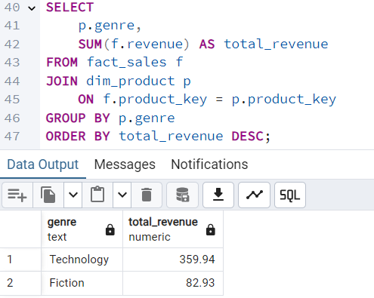
- Number of orders and total revenue per loyalty tier – use COUNT(DISTINCT order_id) to count orders.
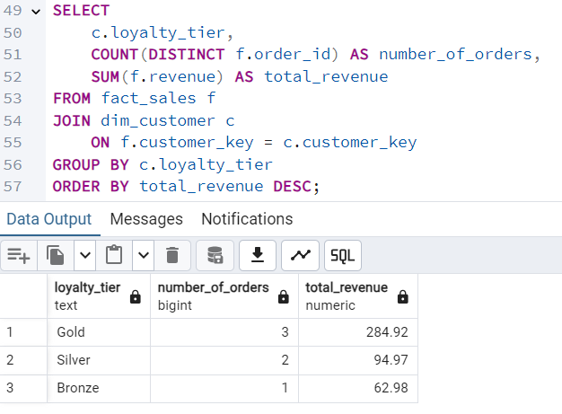

- Monthly total revenue for 2024 – show month name and revenue, ordered by month.
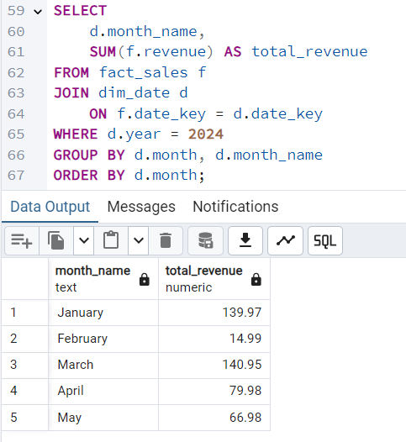

- Top 3 best-selling products (by total quantity sold) – include product title and total quantity.
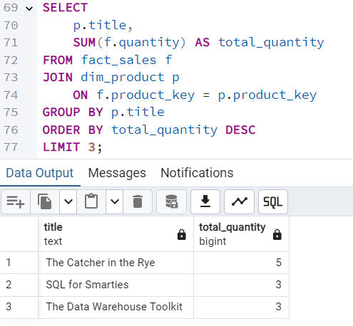

- Average order value (total revenue / number of distinct orders) overall.
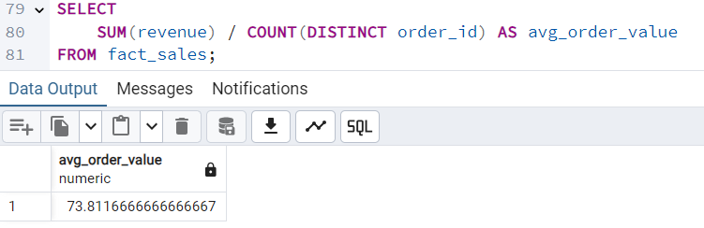

- Customers who have spent more than $100 – show customer name and total spent.
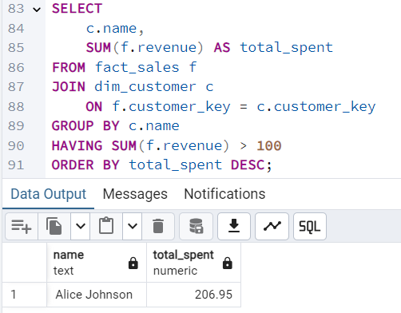
- Slowly Changing Dimension
Currently, dim_customer uses Type 1 – when a customer’s loyalty tier changes, the existing row is overwritten. This loses historical accuracy.
- Explain why this is a problem for analyzing revenue by loyalty tier over time.
Using Type 1 overwrites the existing customer record when the loyalty tier changes. This removes historical information about the customer's previous tier. As a result, past sales are incorrectly associated with the new loyalty tier.
- Propose a new design using Type 2 (add versioning). Sketch the new dim_customer table structure (columns).
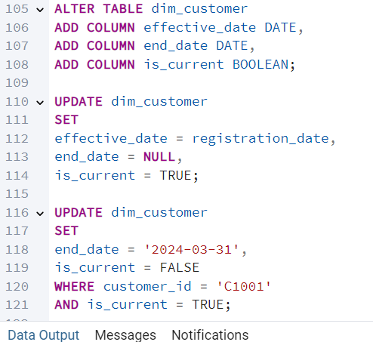
New structure of dim_customer: (customer_key (PK), customer_id, name, email, loyalty_tier, registration_date, effective_date, end_date, is_current)
- Write the SQL statements that would be needed to:
  - Close the old row and insert a new row for a customer whose tier changes from ‘Gold’ to ‘Platinum’ (assume the change happens on 2024-04-01, and the customer is Alice Johnson, customer_id = C1001).


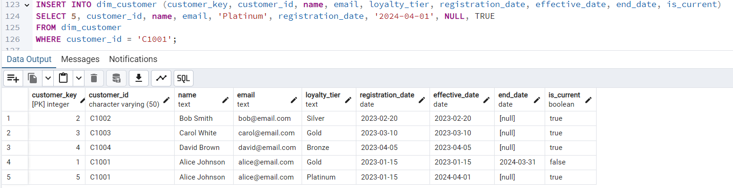
  - Update the fact table references (or explain how existing facts remain correct).
No updates to the fact table are required. The fact table references customer_key, which uniquely identifies each version of the customer. Historical sales remain linked to the old customer_key (Gold), while new sales will use the new customer_key (Platinum). This preserves historical accuracy automatically.

- Reflection
Write a short paragraph (5–7 sentences) answering:
- What business questions become easier to answer with a star schema compared to a normalized transactional schema?
- What are the main trade-offs of denormalizing dimensions?
A star schema makes it easier to answer business questions because it organizes data into a central fact table connected to dimension tables, which simplifies querying and reporting. Compared to a normalized transactional schema, the star schema reduces the number of joins and improves query performance, making analytics faster and more intuitive. However, denormalizing dimensions has trade-offs. It can lead to data redundancy, which increases storage requirements and the risk of inconsistencies. Maintaining the data becomes more complex, especially when updates occur frequently. Overall, star schemas prioritize read and reporting efficiency over strict normalization, which is suitable for analytical workloads.

